**ASSIGNMENT NO.2.**

**Aim :-**Construct a threaded binary search tree by inserting values in the given order and traverse it in inorder traversal using threads.

**Objective:-**To study the concept of threaded binary tree**.**

**Theory:-**

A [binary tree](https://www.includehelp.com/data-structure-tutorial/binary-tree-definition-and-its-properties.aspx) can be represented by using array representation or linked list representation. When a binary tree is represented using linked list representation. If any node is not having a child we use a NULL pointer. These special pointers are threaded and the binary tree having such pointers is called a threaded binary tree. Thread in a binary tree is represented by a dotted line. In linked list representation of a binary tree, they are a number of a NULL pointer than actual pointers. This NULL pointer does not play any role except indicating there is no child. The **threaded binary tree** is proposed by A.J Perlis and C Thornton. There are three ways to thread a binary tree.

1. In the in order traversal When The right NULL pointer of each leaf node can be replaced by a thread to the successor of that node then it is called a right thread, and the resultant tree called a right threaded tree or right threaded binary tree.
2. When The left NULL pointer of each node can be replaced by a thread to the predecessor of that node under in order traversal it is called left thread and the resultant tree will call a left threaded tree.
3. In the in order traversal, the left and the right NULL pointer can be used to point to predecessor and successor of that node respectively. then the resultant tree is called a fully threaded tree.

In the threaded binary tree when there is only one thread is used then it is called as one way threaded tree and when both the threads are used then it is called the two way threaded tree. The pointer point to the root node when If there is no in-order predecessor or in-order successor.

Following diagram shows an example Single Threaded Binary Tree. The dotted lines represent threads.  
[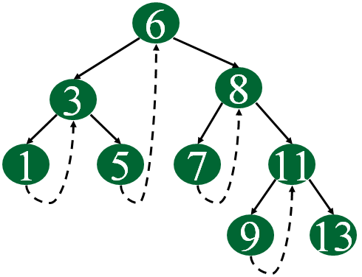](https://www.geeksforgeeks.org/wp-content/uploads/gq/2014/07/threadedBT.png)

**Algorithm:-**

Let **tmp be the newly inserted node**. There can be three cases during insertion:

**Case 1: Insertion in empty tree**  
Both left and right pointers of tmp will be set to NULL and new node becomes the root.

root = tmp;

tmp -> left = NULL;

tmp -> right = NULL;

**Case 2: When new node inserted as the left child**  
After inserting the node at its proper place we have to make its left and right threads points to inorder predecessor and successor respectively. The node which was [inorder successor](https://www.geeksforgeeks.org/inorder-successor-in-binary-search-tree/). So the left and right threads of the new node will be-

tmp -> left = par ->left;

tmp -> right = par;

Before insertion, the left pointer of parent was a thread, but after insertion it will be a link pointing to the new node.

par ->lthread = false;

par -> left = temp;

Following example show a node being inserted as left child of its parent.  
https://cdncontribute.geeksforgeeks.org/wp-content/uploads/threadbinarytree.png  
After insertion of 13,  
https://cdncontribute.geeksforgeeks.org/wp-content/uploads/tbt13inserted.png  
Predecessor of 14 becomes the predecessor of 13, so left thread of 13 points to 10.  
Successor of 13 is 14, so right thread of 13 points to left child which is 13.  
Left pointer of 14 is not a thread now, it points to left child which is 13.

**Case 3: When new node is inserted as the right child**  
The parent of tmp is its inorder predecessor. The node which was inorder successor of the parent is now the inorder successor of this node tmp. So the left and right threads of the new node will be-

tmp -> left = par;

tmp -> right = par -> right;

Before insertion, the right pointer of parent was a thread, but after insertion it will be a link pointing to the new node.

par ->rthread = false;

par -> right = tmp;

**Program Code:-**

#include <iostream>

using namespace std;

class TBT;

class node

{

node *left,*right;

int data;

bool rbit,lbit;

public:

node()

{

left=NULL;

right=NULL;

rbit=lbit=0;

}

node(int d)

{

left=NULL;

right=NULL;

rbit=lbit=0;

data=d;

}

friend class TBT;

};

class TBT

{

node *root; //acts as a dummy node

public:

TBT() //dummy node initialization

{

root=new node(9999);

root->left=root;

root->rbit=1;

root->lbit=0;

root->right=root;

}

void create();

void insert(int data);

node *inorder_suc(node *);

void inorder_traversal();

node * preorder_suc(node *c);

void preorder_traversal();

};

//--------------------------------------------

void TBT::preorder_traversal()

{

node *c=root->left;

while(c!=root)

{

cout<<" "<<c->data;

c=preorder_suc(c);

}

}

void TBT::inorder_traversal()

{

node *c=root->left;

while(c->lbit==1)

c=c->left;

while(c!=root)

{

cout<<" "<<c->data;

c=inorder_suc(c);

}

}

node* TBT::inorder_suc(node *c)

{

if(c->rbit==0)

return c->right;

else

c=c->right;

while(c->lbit==1)

{

c=c->left;

}

return c;

}

node *TBT::preorder_suc(node *c)

{

if(c->lbit==1)

{

return c->left;

}

while(c->rbit==0)

{

c=c->right;

}

return c->right;

}

//-------- Create Method

void TBT::create()

{

int n;

if(root->left==root&&root->right==root)

{

cout<<"\nEnter number of nodes:";

cin>>n;

for(int i=0;i<n;i++)

{

int info;

cout<<"\nEnter data: ";

cin>>info;

this->insert(info);

}

}

else

{

cout<<"\nTree is Already created.\n";

}

}

void TBT::insert(int data)

{

if(root->left==root&&root->right==root) //no node in tree

{

node *p=new node(data);

p->left=root->left;

p->lbit=root->lbit; //0

p->rbit=0;

p->right=root->right;

root->left=p;

root->lbit=1;

cout<<"\nInserted start"<<data;

return;

}

node *cur=new node;

cur=root->left;

while(1)

{

if(cur->data<data) //insert right

{

node *p=new node(data);

if(cur->rbit==0)

{

p->right=cur->right;

p->rbit=cur->rbit;

p->lbit=0;

p->left=cur;

cur->rbit=1;

cur->right=p;

//cout<<"\nInserted right "<<data;

cout<< data<<" Inserted right"<<" of "<< cur->data<<endl;

return;

}

else

cur=cur->right;

}

if(cur->data>data) //insert left

{

node *p=new node(data);

if(cur->lbit==0)

{

p->left=cur->left;

p->lbit=cur->lbit;

p->rbit=0;

p->right=cur; //successor

cur->lbit=1;

cur->left=p;

cout<<data <<" Inserted left "<<" of "<<cur->data<<endl;

return;

}

else

cur=cur->left;

}

}

}

int main() {

TBT t1;

int value;

int choice;

do

{

cout<<"\n1.Create Tree\n2.Insert into tree\n3.Preorder\n4.Inorder\n0.Exit\nEnter your choice: ";

cin>>choice;

switch(choice)

{

case 1:

t1.create();

break;

case 2:

cout<<"\nEnter Number(data): ";

cin>>value;

t1.insert(value);

break;

case 3:

cout<<"\nPreorder traversal of TBT\n";

t1.preorder_traversal();

break;

case 4:

cout<<"\nInoder Traversal of TBT\n";

t1.inorder_traversal();

break;

default:

cout<<"\nWrong choice";

}

}while(choice!=0);

return 0;

}

**Output Screenshots:-**

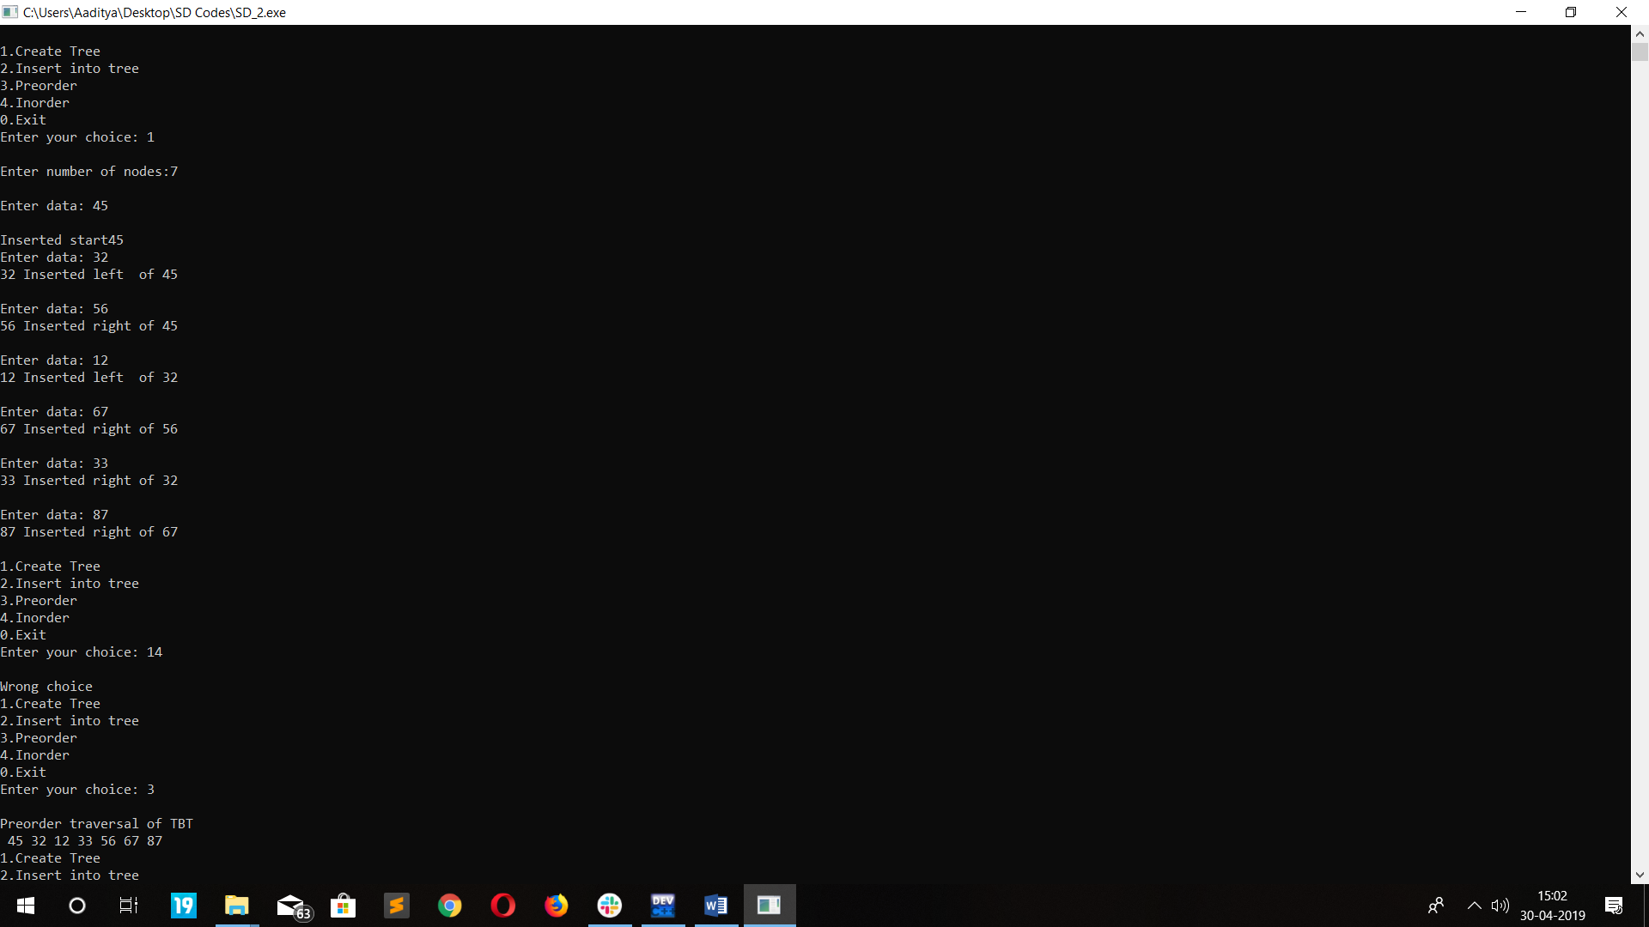

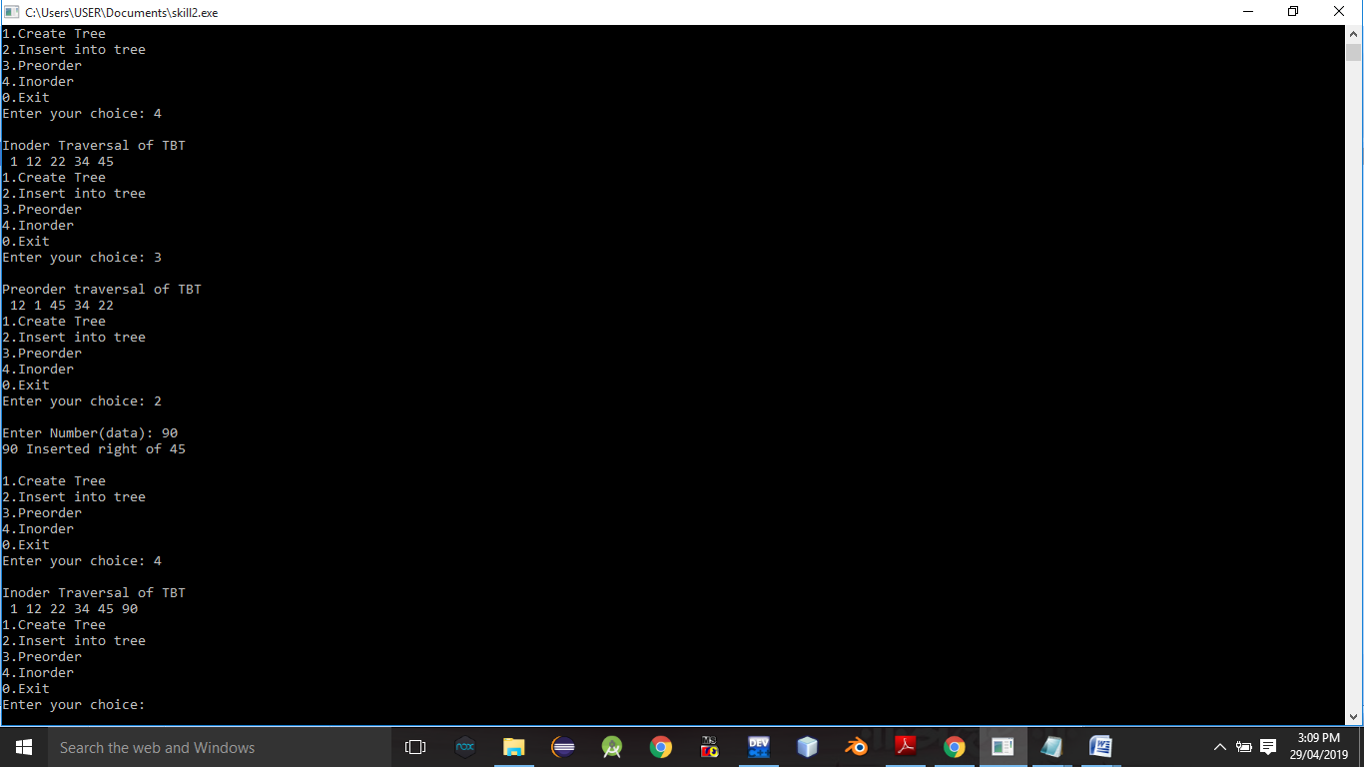

**Conclusion:-**Thus,we have studied Threaded binary tree.